**IPL Match Insights**

## Overview of the Dataset:

The dataset contains detailed information about cricket matches from multiple seasons. It has **756 records (rows)** and **16 columns**, covering match details such as the teams playing, the season, venue, toss results, match winner, player of the match, and win margins. This dataset is useful for analyzing team performance, understanding patterns in match outcomes, and predicting future match results.

### Columns details:

|  |  |
| --- | --- |
| **Column Name** | **Description** |
| id | Unique identifier for each match |
| Season | Year of the IPL Seasion |
| city | City where the match was played |
| date | Date of the match |
| team1 | First team playing |
| team2 | Second team playing |
| toss_winner | Team that won the toss |
| toss_decision | Choice made by toss-winning team |
| result | Type of Result |
| winner | Them that won the match |
| win_by_run | Runs margin of victory |
| win_by_wickets | Wickets margin of victory |
| player_of_match | Player awarded “Player of the Match” |
| venue | Ground where the match was played |
| umpire1 | First umpire officiating the match |
| umpire2 | Second umpire officiating the match |

## Data Preprocessing:

### Import CSV File:



### Columns Overview:

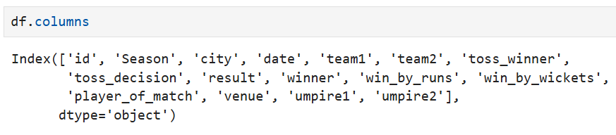

### Check missing Value:

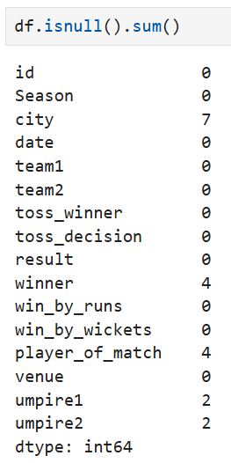

### Handle missing Value:

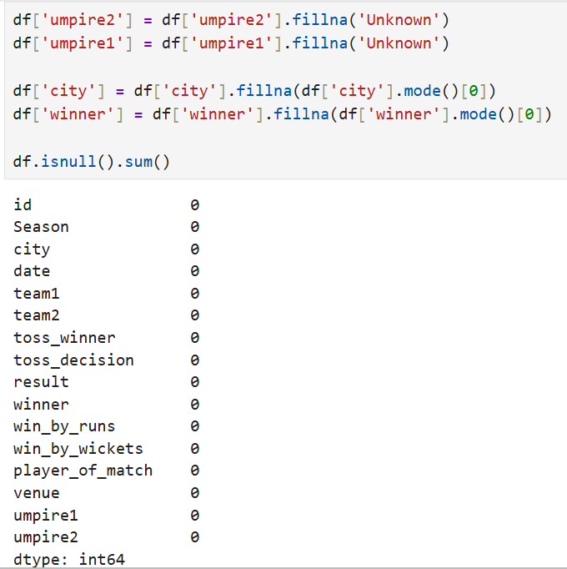

### Data types of all columns:

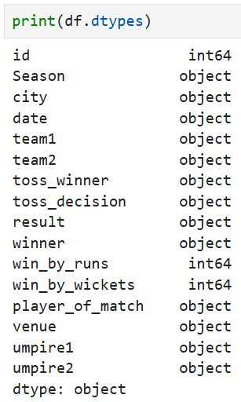

### Data information of all Columns:

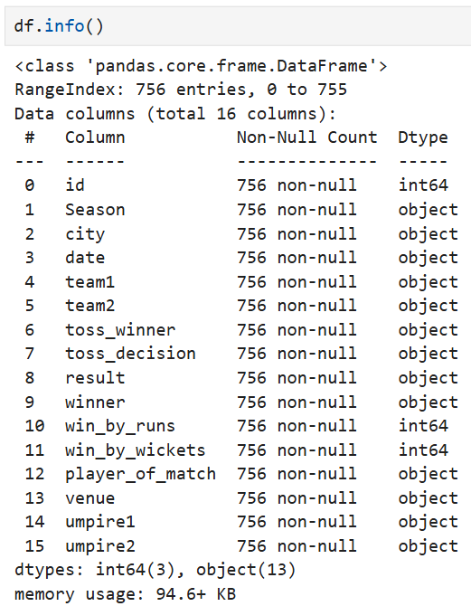

### Describe dataset:

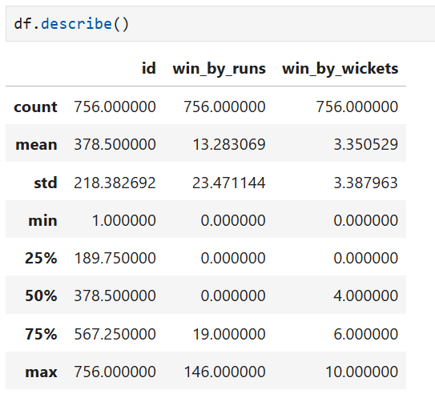

### Check and Handle Duplicates:

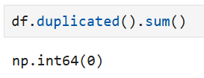

### shape of Dataset:

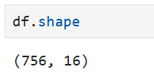

### Replace Data to short Form:

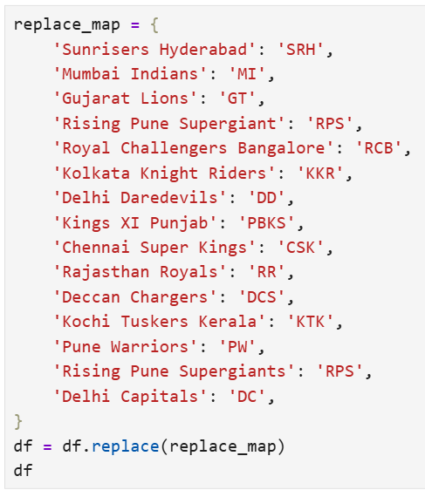

### Finding which IPL team scored the maximum runs:

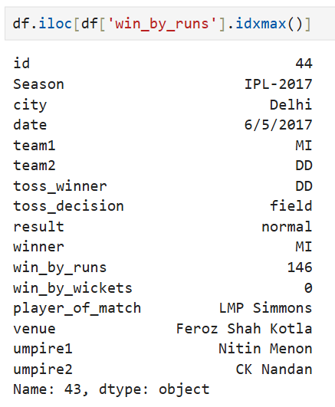

### which team won by scoring maximum wickets:

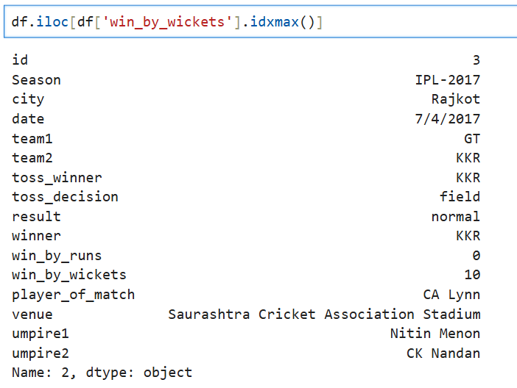

## EDA (Exploratory Data Analysis):

### Univariate Analysis:

#### Q1. Which season had the most matches?

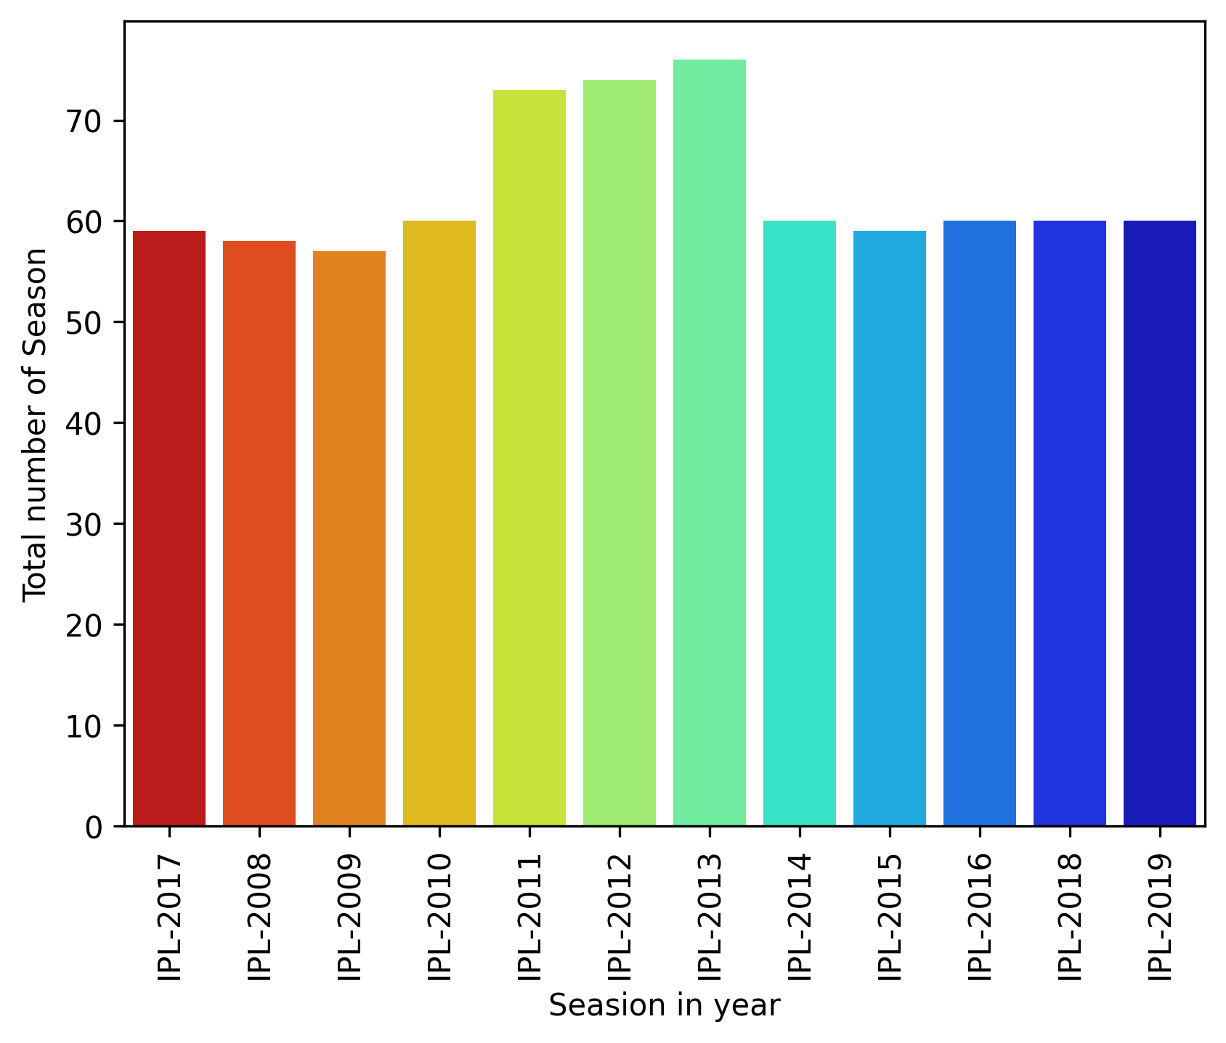

#### Q2. Which city hosted the most matches?

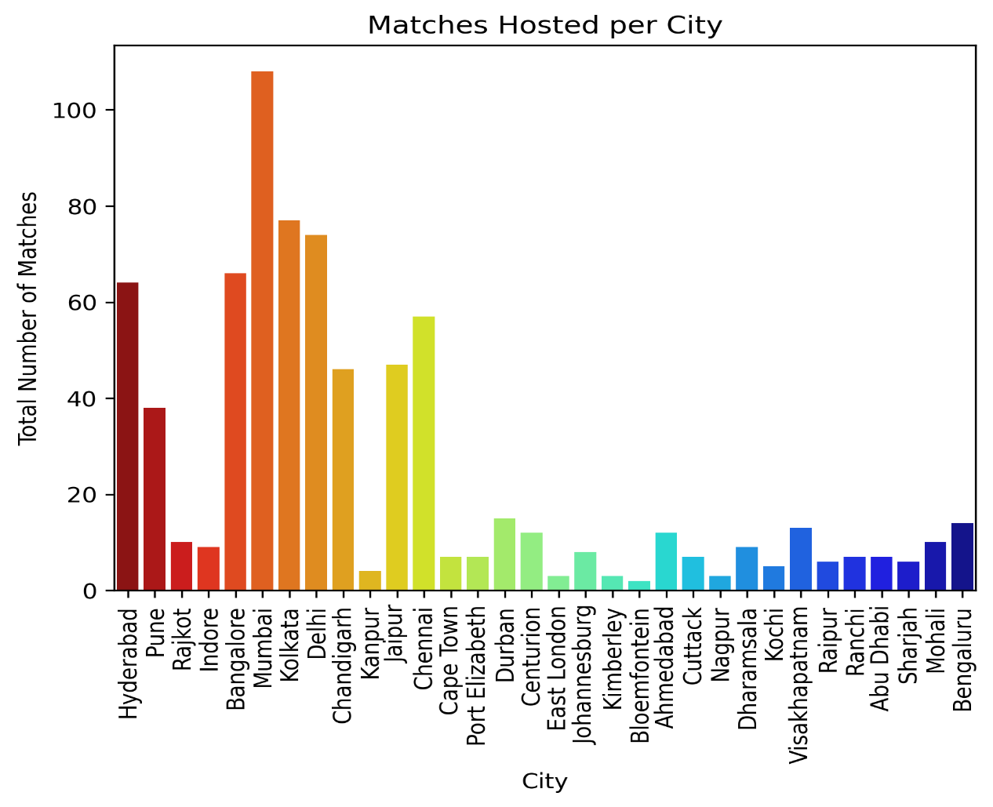

#### Q3. Which team appears most frequently as Team1?

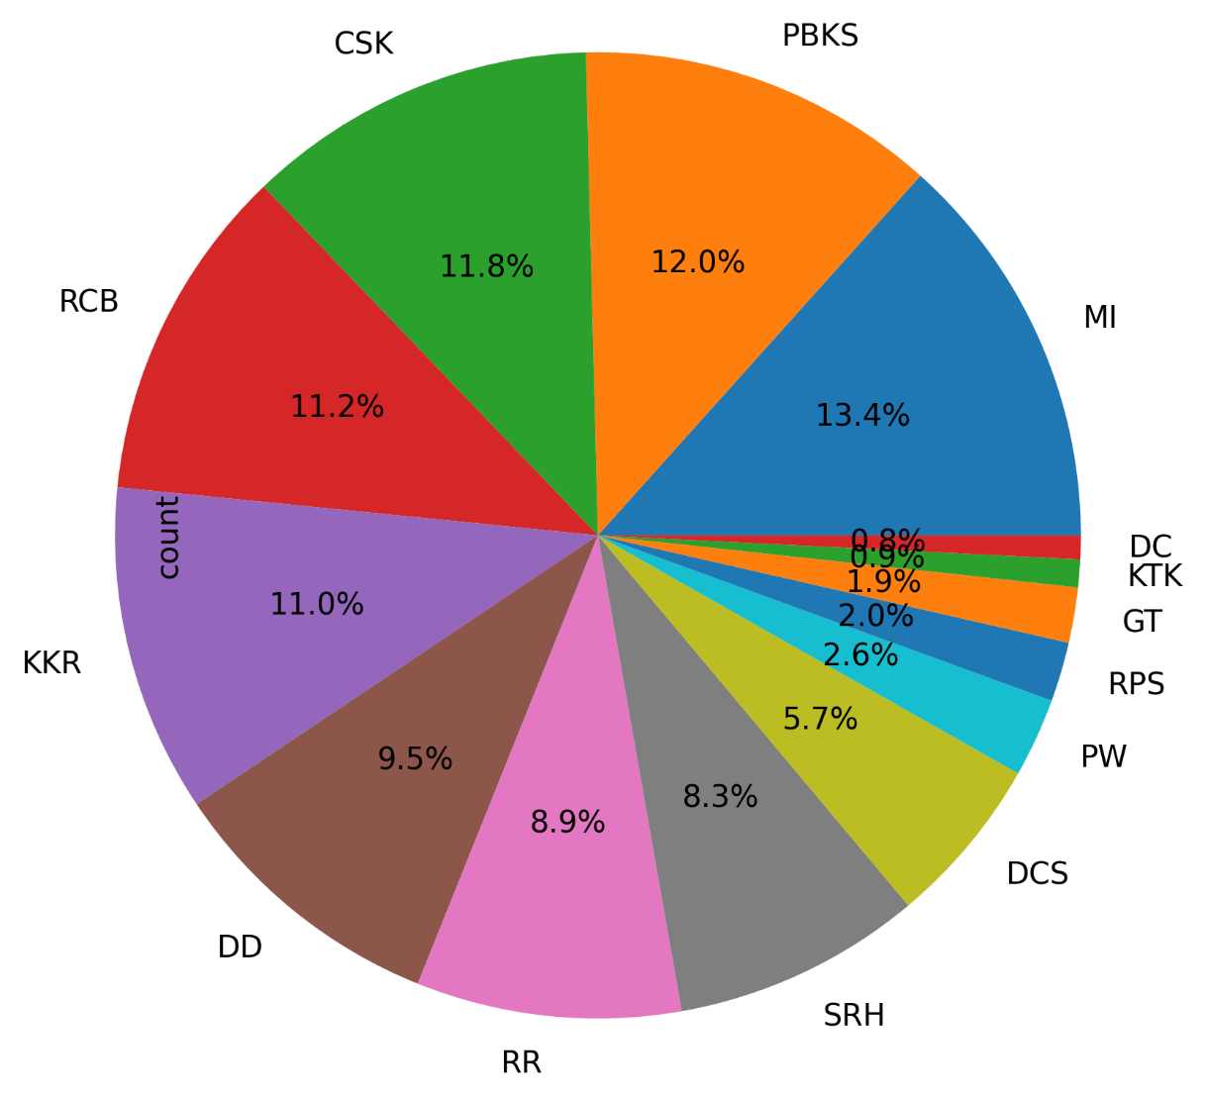

#### Q4. Which team appears most frequently as Team2?

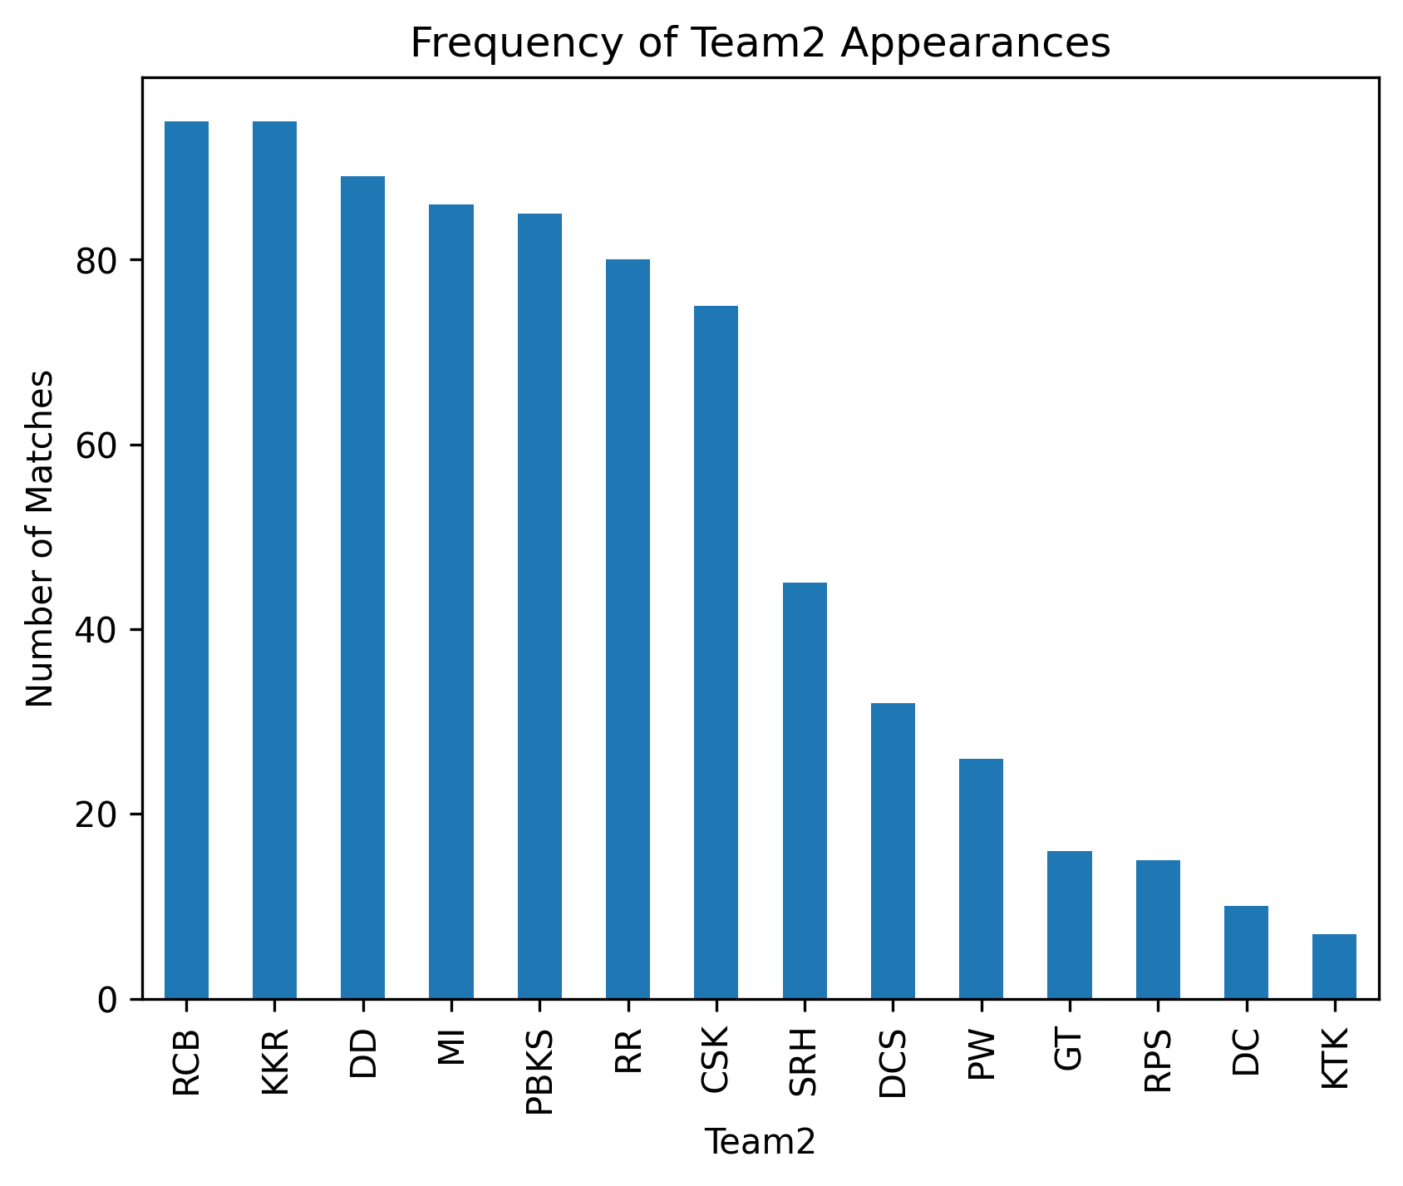

#### Q5. Which team won the toss most often?

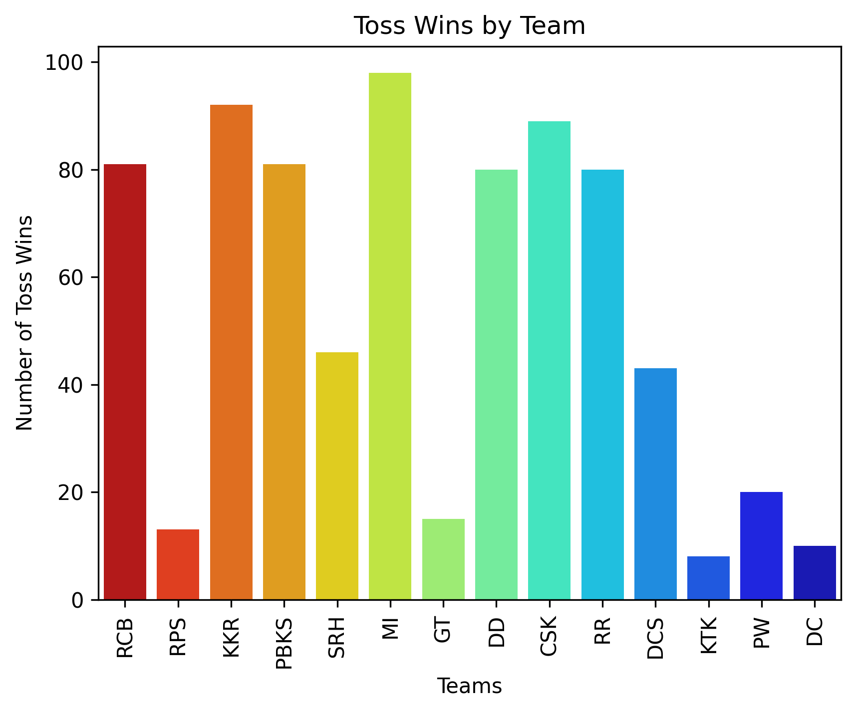

#### Q6. Which toss decision was chosen most often (bat/field)?

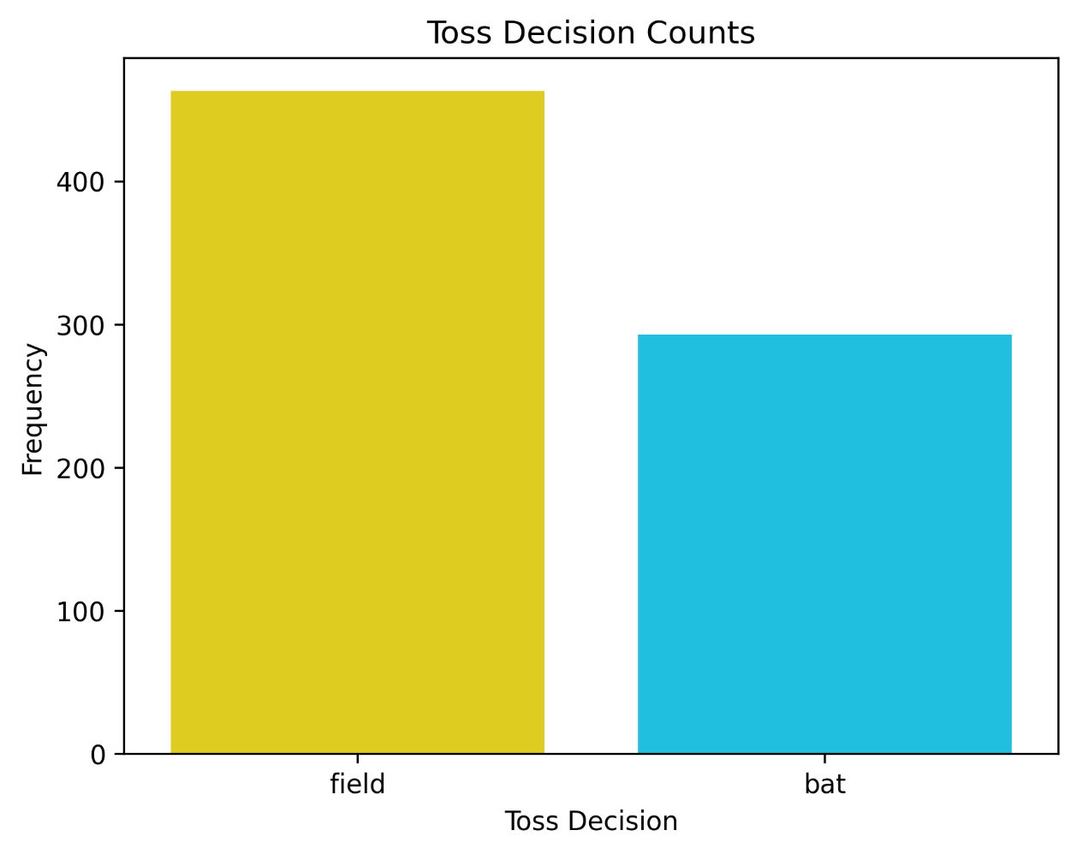

#### Q7. Which result type occurred most frequently (normal/tie/no result)

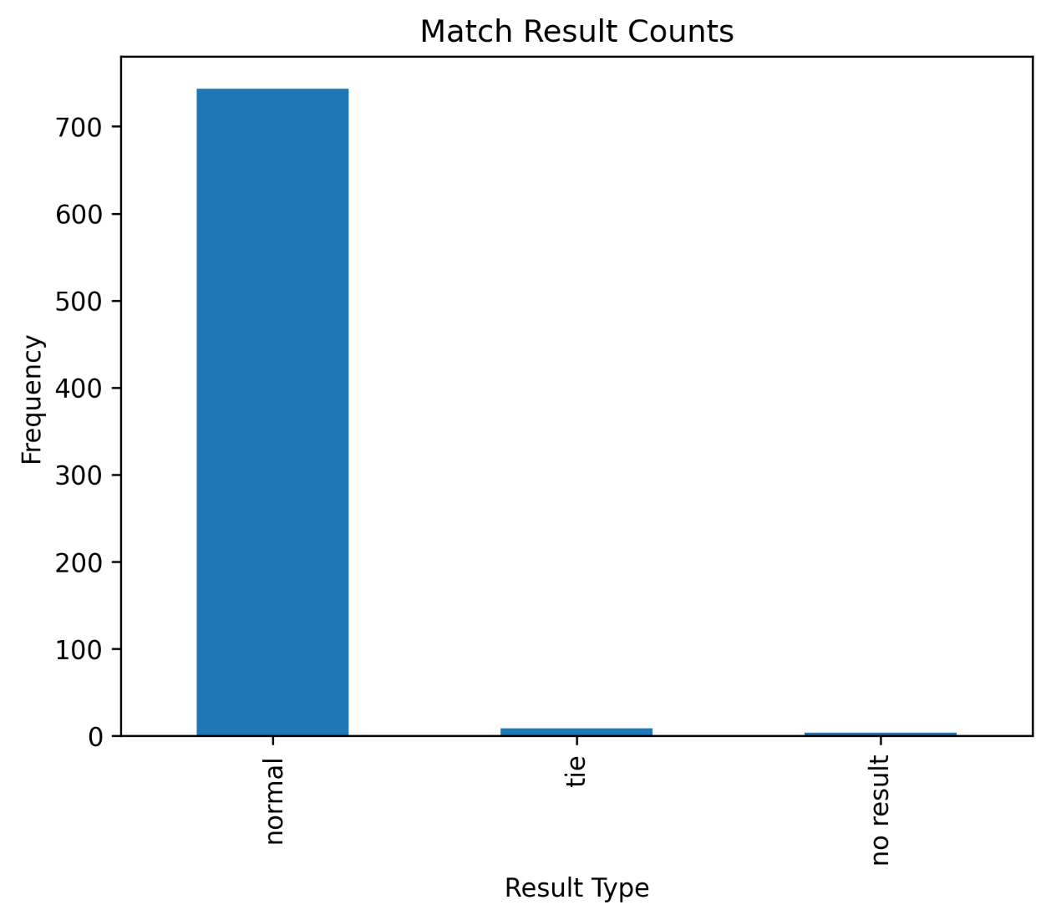

#### Q8. Which team won most matches?

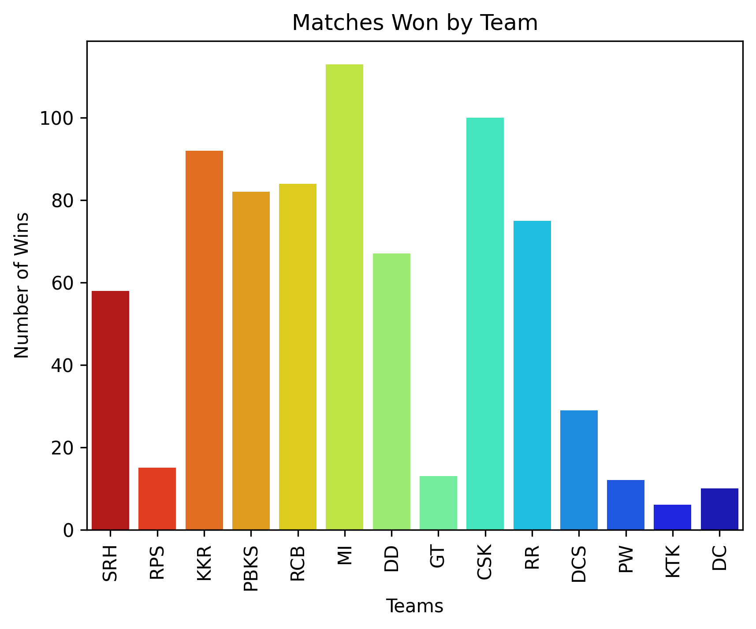

#### Q9. Which stadium hosted the most matches?

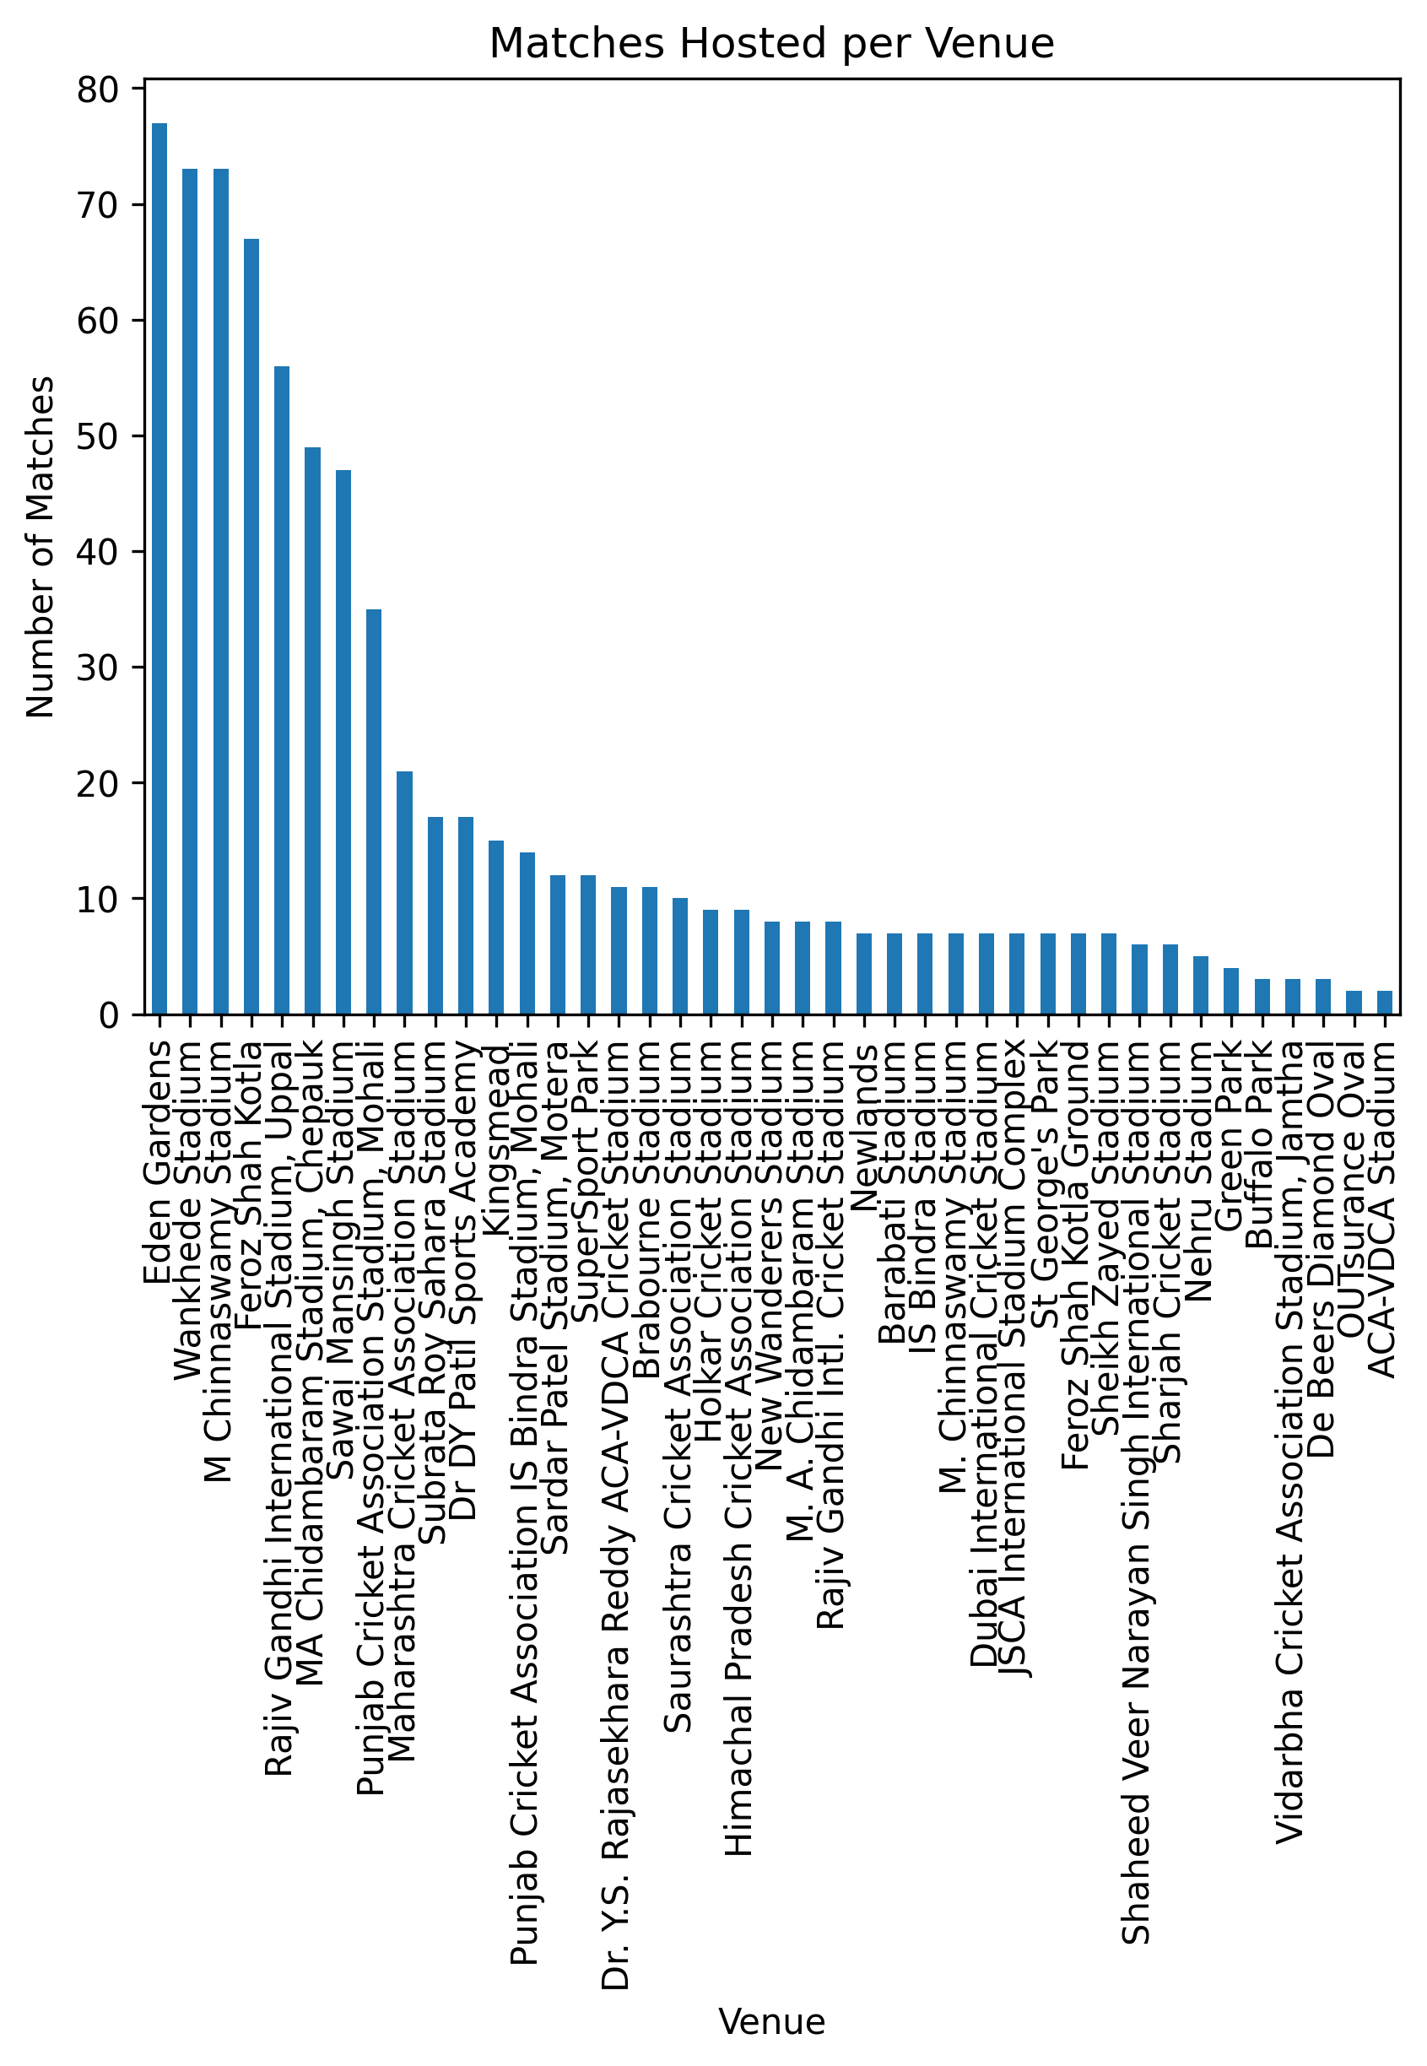pire

#### Q10. Distribution of win margins by runs

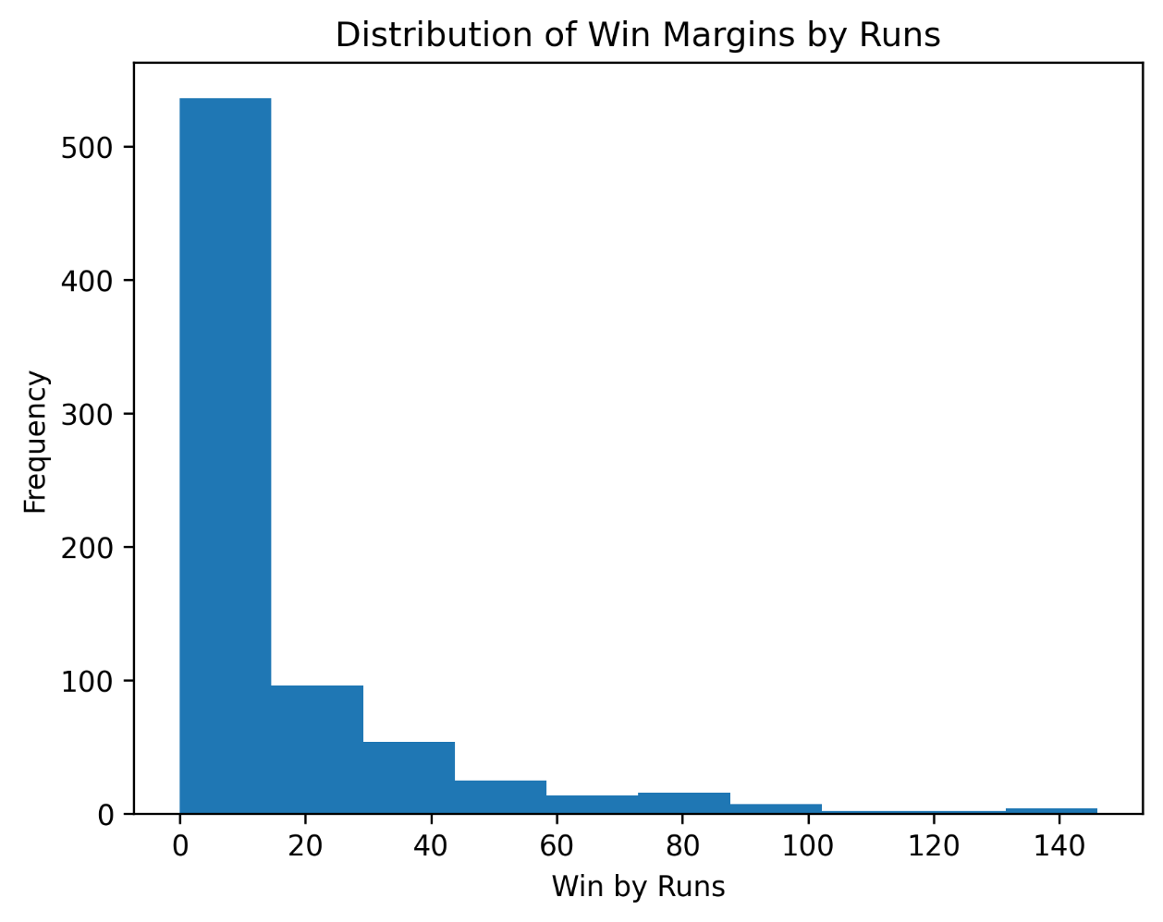

#### Q11. Distribution of win margins by wickets

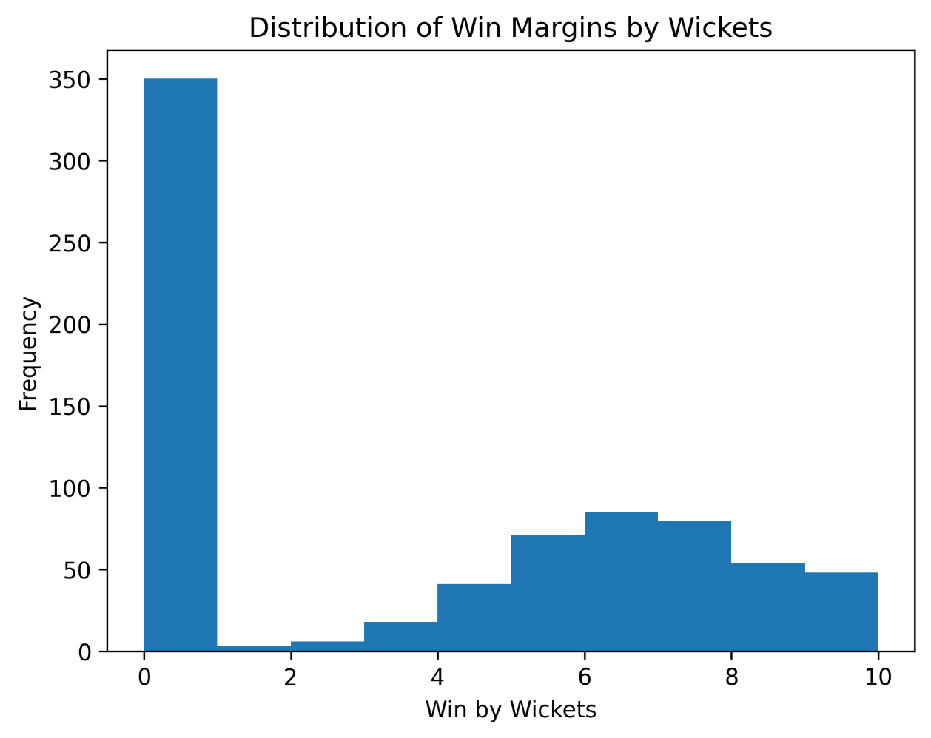

#### Q12. Top 10 Most frequently used umpire1.

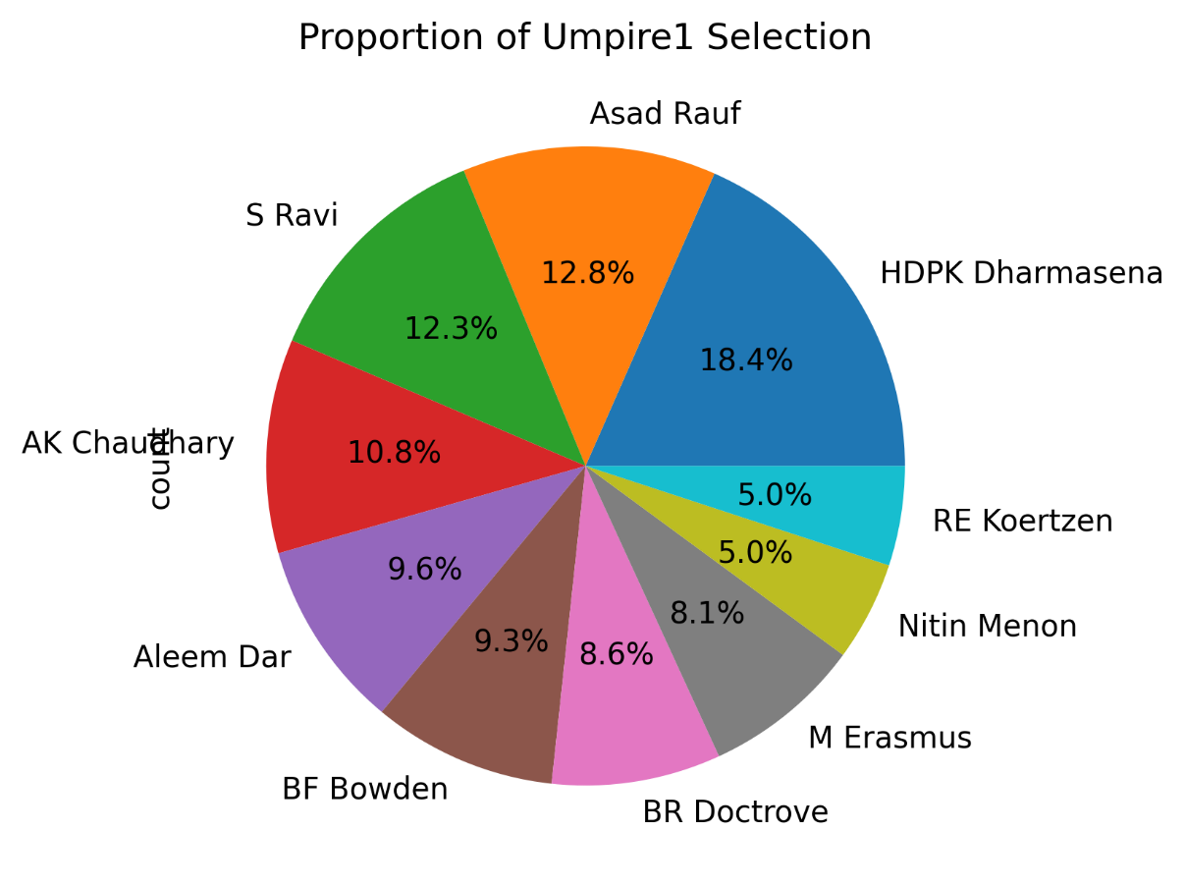

#### Q13. Top 10 Most frequently used umpire2.

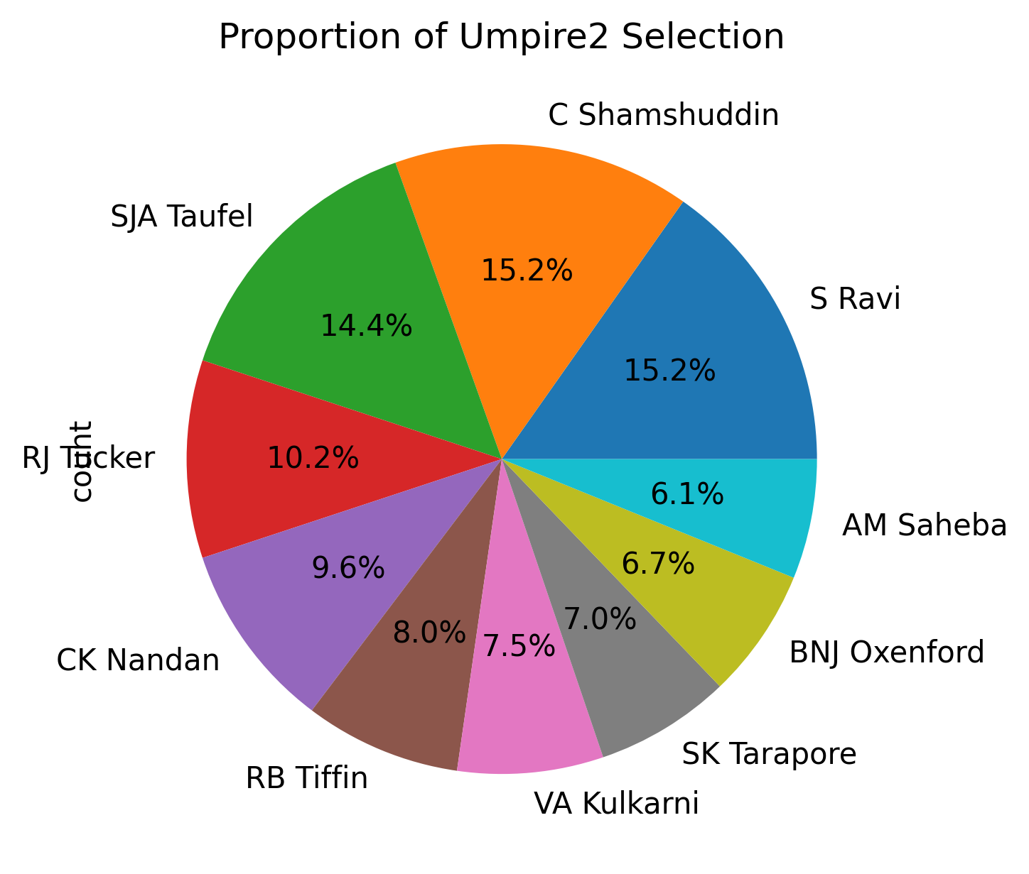

### Bivariate Analysis:

#### Q1. Are thrillers becoming more common?

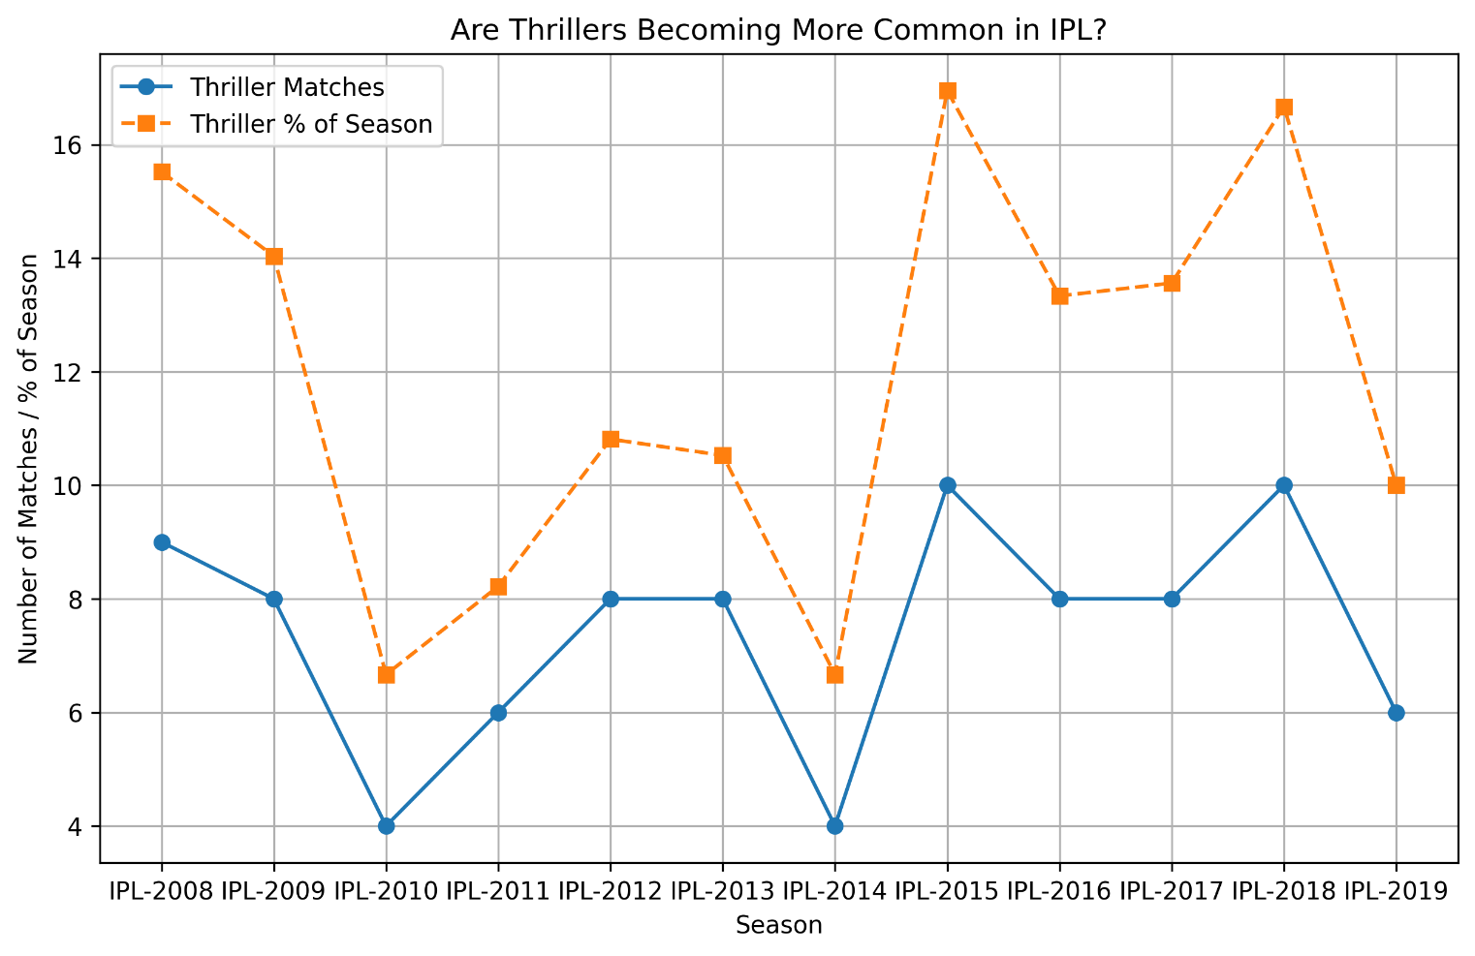

#### Q2. Does batting/fielding first matter?

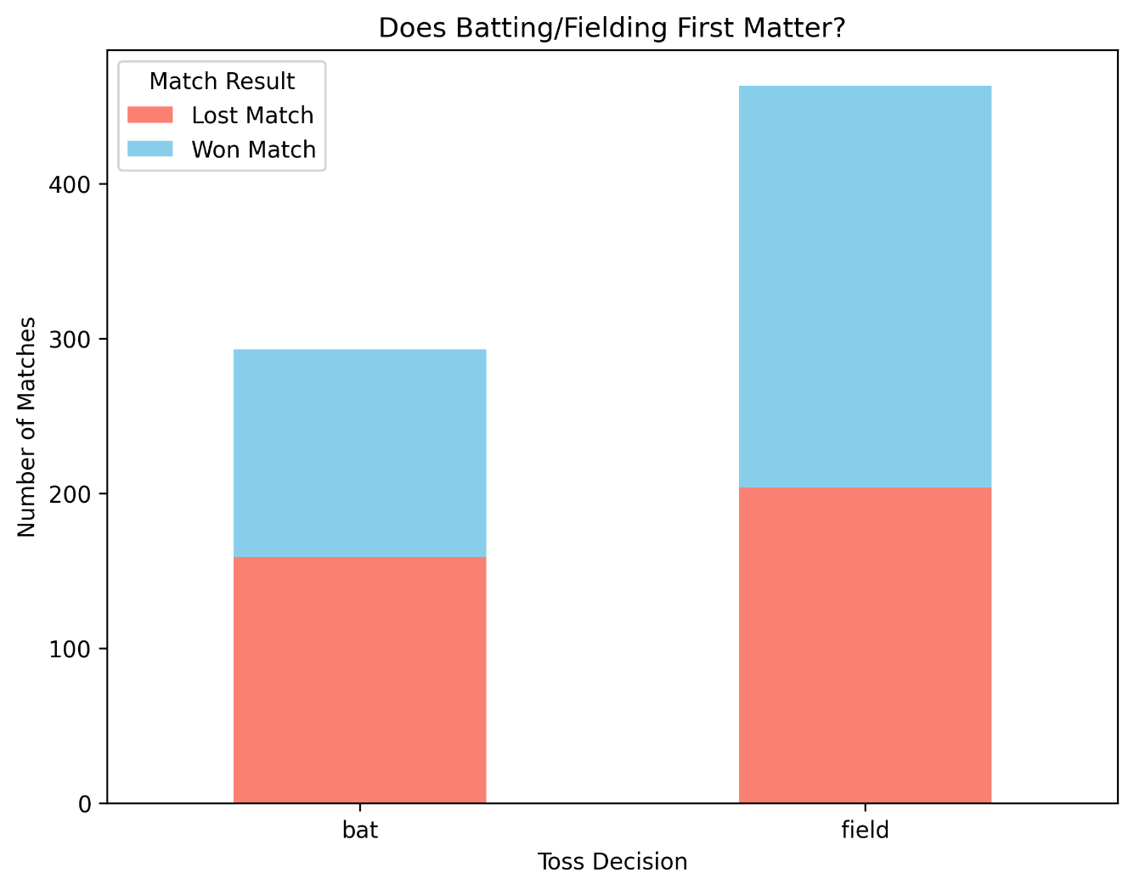

#### Q3. Are matches ending in “No Result” increasing?

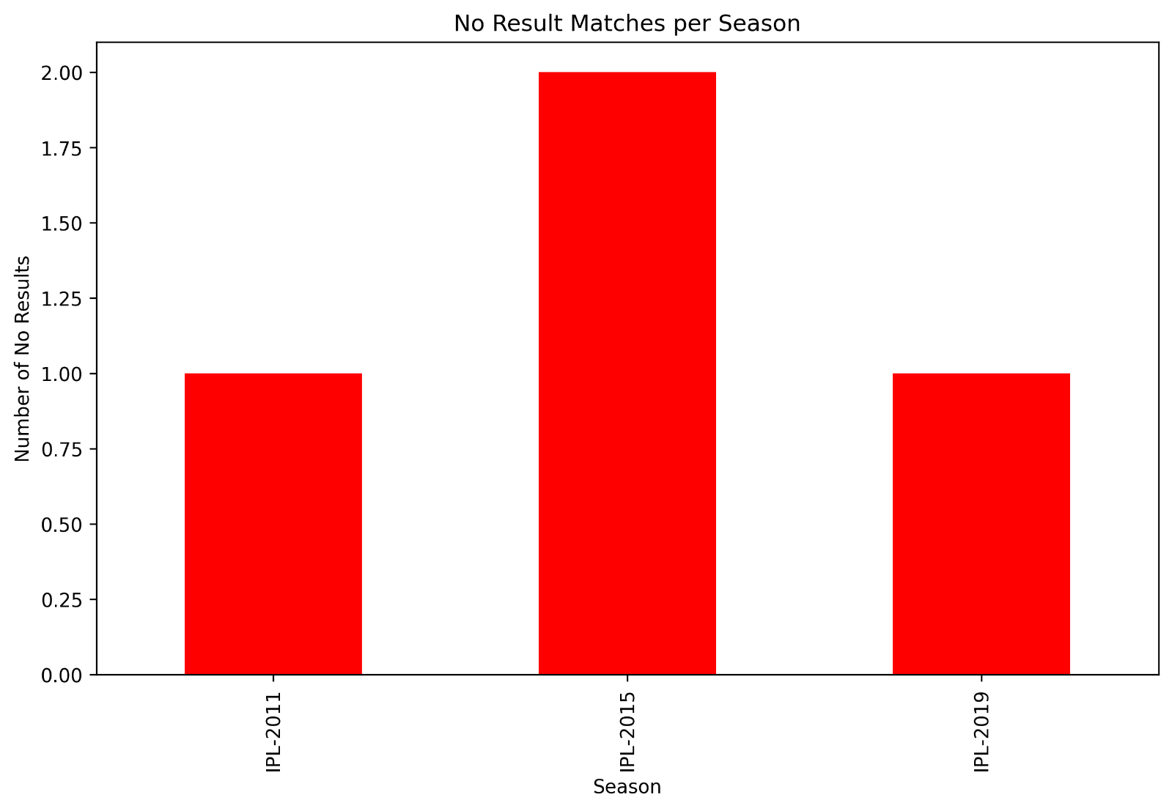

#### Q4. How often do matches go into Super Overs (Ties)?

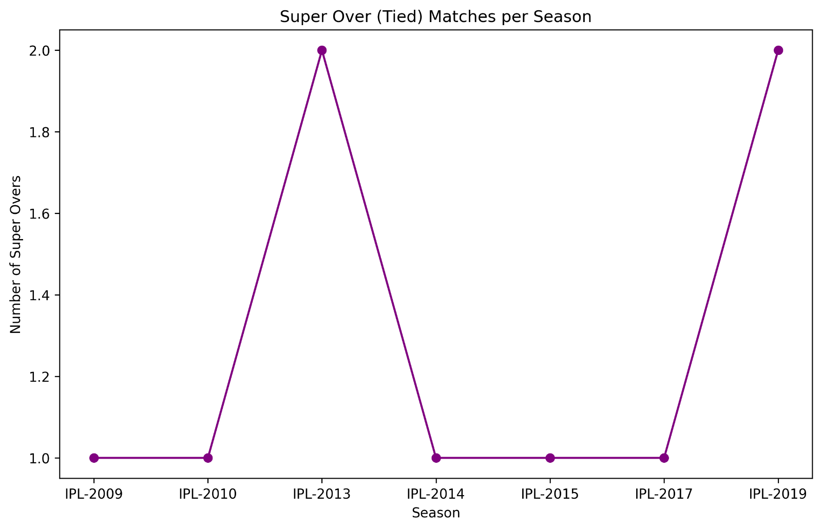

#### Q.5 Which teams dominate at home vs away venues?

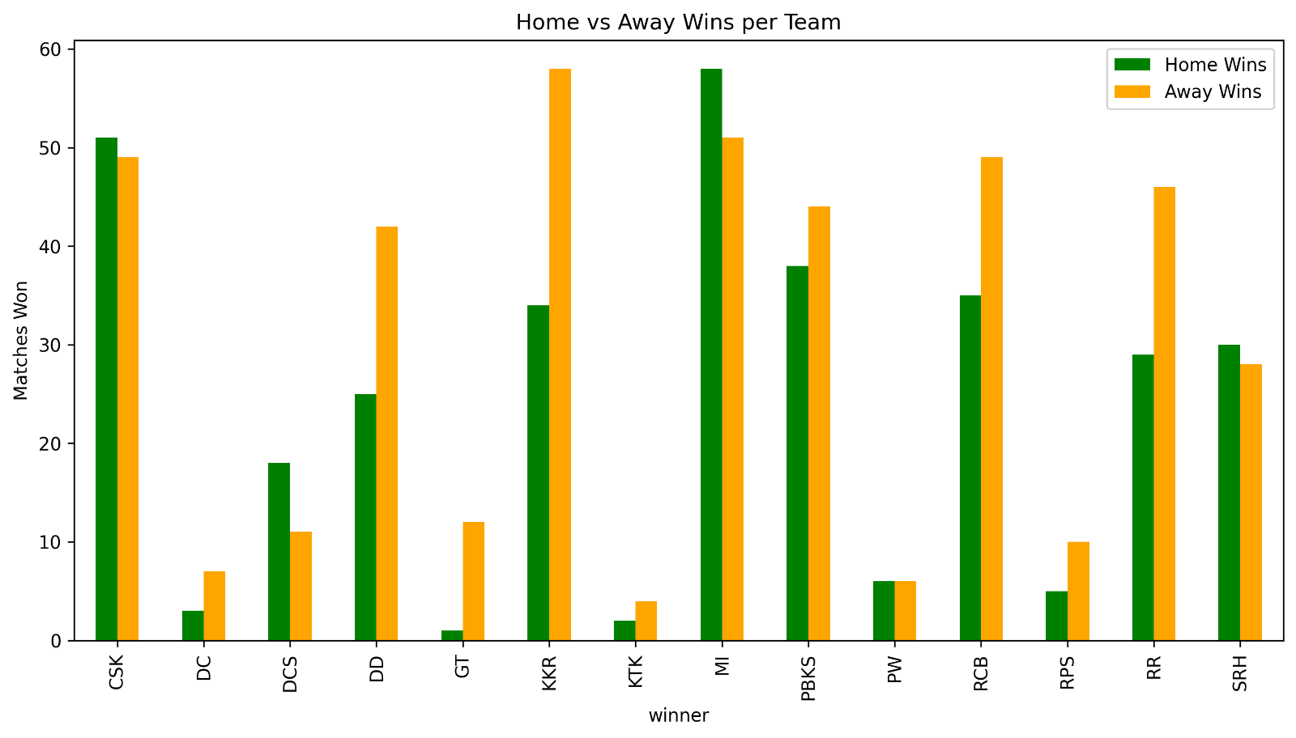

#### Q.6 Who wins Player of the Match in finals most often?

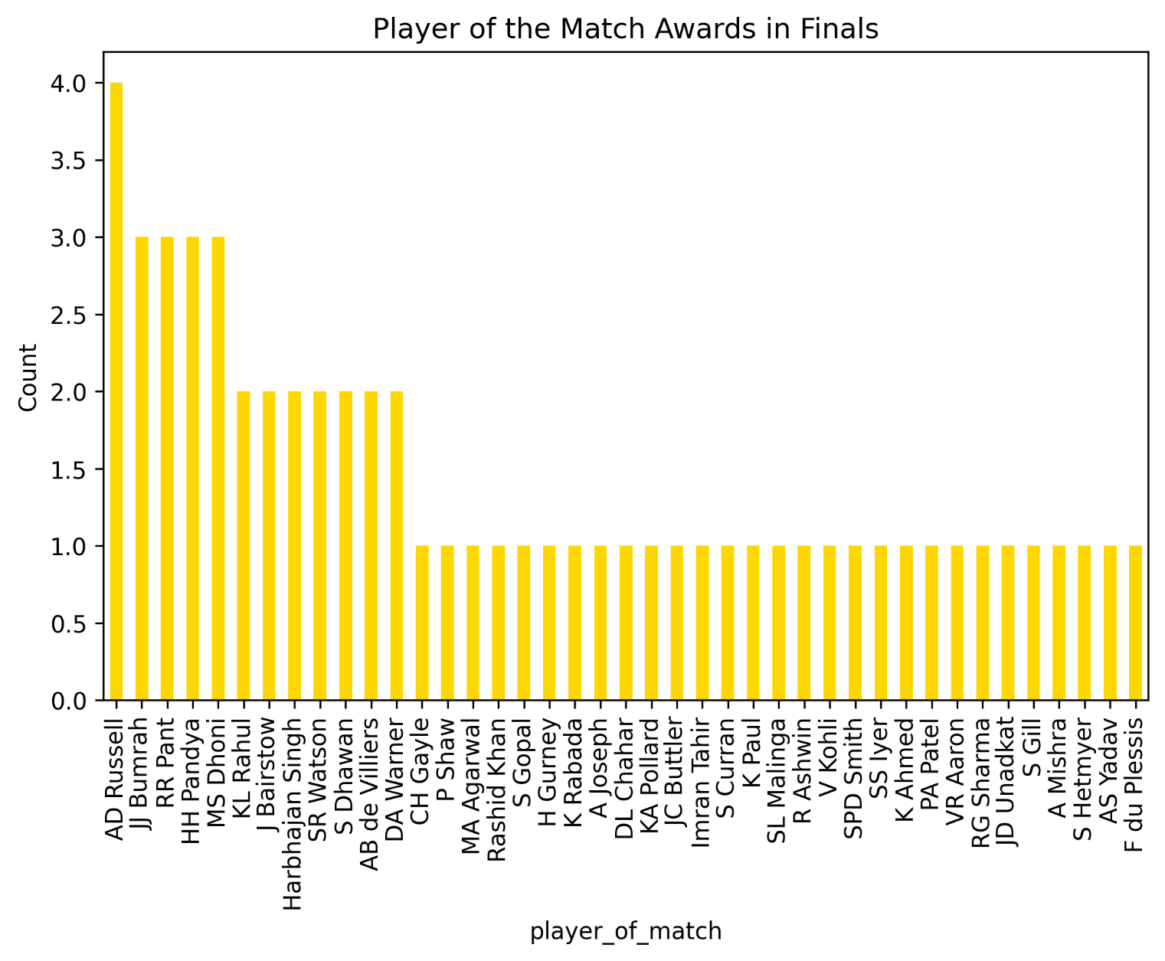

## Multivariate Analysis:

#### Q1. Across seasons, which teams win more by batting first (runs) vs chasing (wickets)?

